**Database Design**

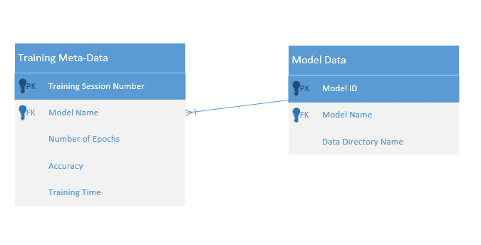

The database will be used to store metadata about the user’s training on the model. More data can be added as we get deeper into the machine learning training process ourselves and see what kind of data is useful to a user after training to improve models.

**Class Diagram:**

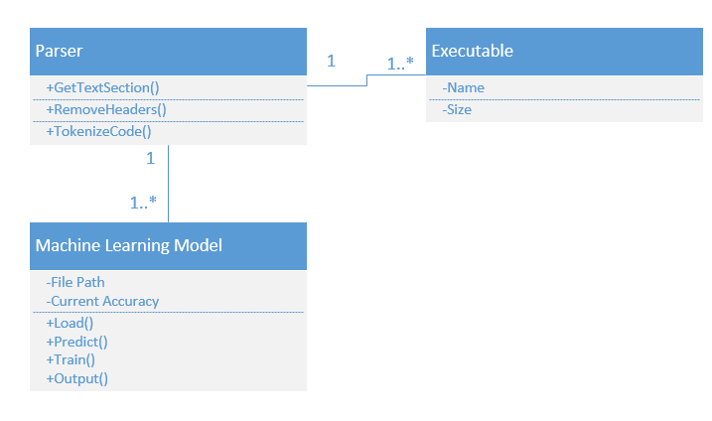

The parser will read the text in and tokenize it to conform to our data standards. It will then run through our algorithm which will load the data from the file path, make prediction based on current nodes, and then evaluate the results and adjust the node weights accordingly.